RHYTHMIC TUNES

Submitted BY

Vijayasri R

Yuvadharshini D

SofiyaFathima T

Yamini R

Sathyasri S

Life itself has a rhythm

· SUBMITTED BY:

· Vijaya sri R

· Yuva Dharshini

· Yamini R

· Sofiya Fathima

.Sathyasri

II BSC CS ‘B’

SHRI SHANKARLAL SUNDARBAI SHASUN JAIN COLLEGE FOR WOMENS CHENNAI -17

**Team leader**: Vijayasri R- vijayasrirengaraj@gmail.com

**Team Members**: Yamini [R-yaminichandran34@gamil.com](mailto:R-yaminichandran34@gamil.com)

Sofiyafathima [-sofiyabadar27@gmail.com](mailto:-sofiyabadar27@gmail.com)

Sathyasri [-srigeethu333@gmail.com](mailto:-srigeethu333@gmail.com)

[Yuvadharshini-yuvadharshini260707@gmail.com](mailto:Yuvadharshini-yuvadharshini260707@gmail.com)

INTRODUCTION:

**Every beat is a step, every rhythm a journey.** *Rhythmic Tunes* is a project that delves into how beats, patterns, and timing generate energy, structure, and emotion in music. Rhythm lays the groundwork for melody and harmony, steering tempo and movement while connecting listeners through a shared pulse of time. From classical symphonies and folk traditions to modern pop and electronic soundscapes, rhythm defines the character of every composition and shapes the mood for audiences worldwide.

This project explores rhythmic elements such as tempo, meter, and time signatures, alongside their cultural and historical depth. It highlights how diverse musical traditions—ranging from the intricate tala cycles of Indian classical music to the powerful drum patterns of Africa and the syncopated swing of Western jazz—reflect the richness of rhythmic expression. The research also investigates how rhythm influences human emotions and physical responses, revealing its power to uplift moods, spark dance, and strengthen social connections.

Through analysis, active listening, and creative experimentation, *Rhythmic Tunes* seeks to present rhythm not as a mere background layer but as the driving force of music itself—a pulse that fuels creativity, unites cultures, and transforms every musical journey into a vibrant and unforgettable experience.

Rhythmic Tunes is a front-end music-streaming web application crafted with React.js, Vite, CSS, and Bootstrap.

It enables listeners to play songs, browse by performer/genre/title, mark favorites, and create custom mixes through a clean, intuitive design.

Component Hierarchy

**App.jsx**: Core component that manages routing.

**Navbar / Sidebar**: Handles navigation (All Songs, Favorites, Playlists).

**Songs Module**: Shows all tracks from db.json.

**Favorites Module**: Displays the user’s liked tracks.

**Playlist Module**: Presents custom song lists.

**Player Module**: Audio console with play/pause controls.

**SearchBar**: Filters tracks by artist, style, or title.

State Handling

Local: Managed with useState for search text, active track, and form updates.

Data: Synced with db.json using Axios and useEffect.

props drilling is used for passing data globally.

Routing Paths

/ → Songs

/favorites → Favorites

/playlist → Playlist

Music enthusiasts often struggle with:

Organizing extensive track libraries

Limited playlist flexibility in basic apps

Interfaces that discourage regular use

Rhythmic Tunes counters these issues with a lightweight, easy-to-navigate music companion featuring personalized mixes, favorites, and seamless playback.

Goals

**Intuitive Design**: Let users browse, save, and sha

re music effortlessly.

**Robust Streaming**: Manage songs with advanced lookup options.

**Modern Stack**: Built with React.js, Vite, and Tailwind CSS for speed and efficiency.

Scope

Comprehensive song archive with metadata (title, performer, style, cover art, audio URL)

Advanced search by song name, genre, or artist

Playlist creation and management

Favorites (wish-list) feature

One-track-at-a-time audio control

Hardware

**CPU**: Intel i3 or higher (i5 suggested)

**RAM**: 4 GB minimum (8 GB recommended)

**Storage**: 10 GB free

**Display**: 1366×768 or above

Software

**OS**: Windows 10/11, macOS, or Linux

**Languages**: JavaScript (ES6+), JSX, HTML, CSS

**Framework**: React.js (v18.2.0)

**Styling**: Tailwind CSS & Bootstrap

Build Tool: Vite

**Version Control**: Git & GitHub

**Package Manager**: npm

**Browser**: Chrome, Firefox, or Edge

Testing confirmed:

Accurate song retrieval

Instant favorite/unfavorite updates

Persistent playlist management

Reliable search filtering

Single-track audio playback

Smooth performance across desktop and mobile

Output Pages:

Songs Library, Favorites, Playlist, Now Playing

**Coding screenshot**

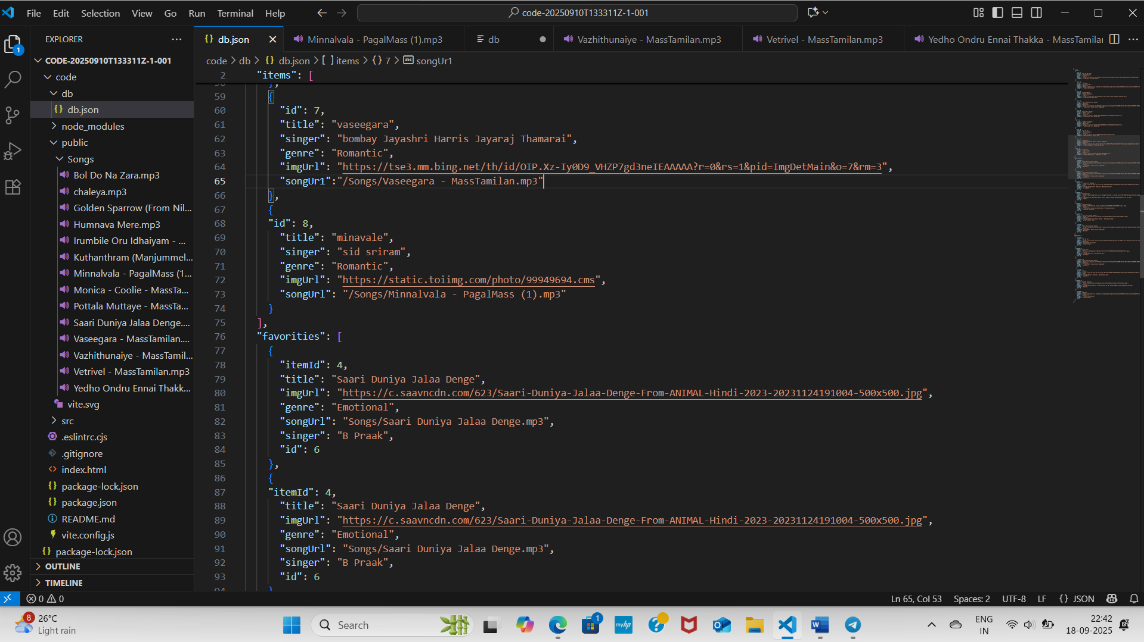

Coding screenrecorder video

https://drive.google.com/drive/folders/10f_6EvVIoqzU74WogFwR8A-8AS62XdEs